Full Name: Sean Thabo Ndlovu Date: 25/03/2021

Student ID: 15932

Year: 2020/2021

Course: Computer Science

Subject: Internship

Supervisor: Mr Przymslaw Zarnecki

Internship Report

# Introduction

During the course of this internship, I was given the opportunity to apply my acquired knowledge from my CS degree, more specifically the knowledge I gained in graphic designing through various adobe tools, through applying Agile methodologies to create a minimalistic yet still sleek Logo for a psychology company. Through the course of creating this Logo I believe I have gained a much wider understanding of the process that goes into the general design of a company’s graphic in this case its logo I have also gained a deeper love and respect for graphic designing through computer systems and software.



# Purpose of this Activity

Through communication with Mr Zarnecki I managed to take on a special project where I was instructed to create a Logo design for a company that deals with specialized services concerning mental health in other words a Psycologist company. There were other projects that were suggested but I decided to take this one because I believed it would be helpful to me in gaining some experience in graphic design as that is the IT field I have the least experience in but most interested in.

In the beginning I was very idle with this project but once I began I put all my effort into it; I started by doing research into similar companies and their logos to see what they usual designs usually are. I then looked into the applications that would be required to execute this project.

During my research I also found several companies which specialize in this field so when analyzing the design of these logos I decided to try something a little different with my design by making it sleek, simplistic and straight to the point .



First Attempt

In the beginning I attempted to take different images and use photoshop in attempt to create the logo but as I continued to make some more research on a design process of this type I learned that it is actually easier to create something from scratch and digitize it to fit my goals. I then made a line sketch on actual paper to better visualize my design

1.first design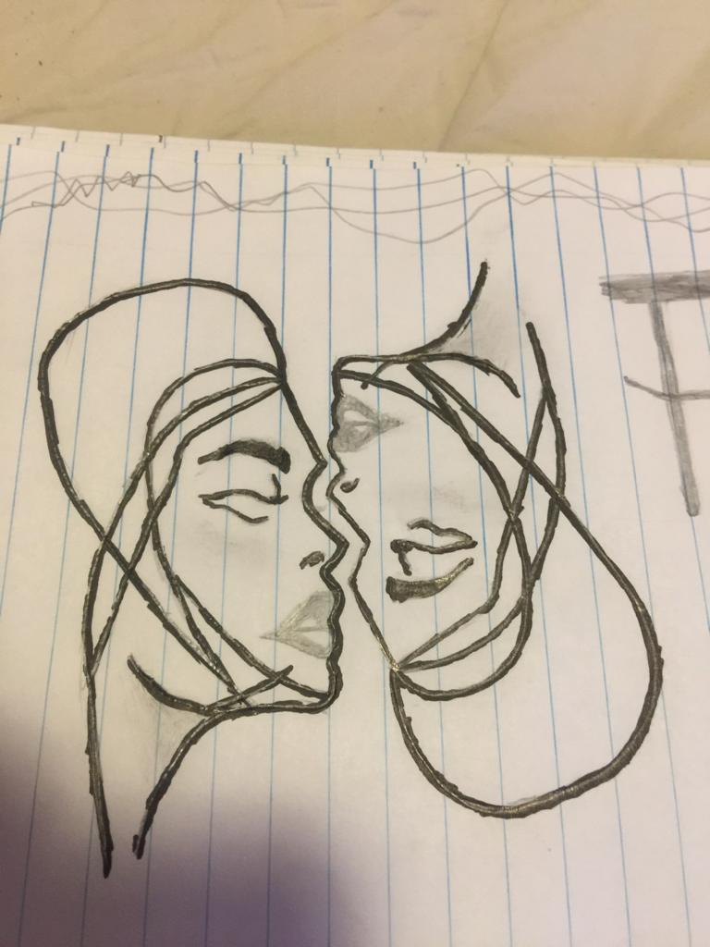

The design is inspired by the way most mental health institutions represent themselves which is by using an image to depict mental confusion or uncertainty as that is the target market, patients who are unable to function in society due to the confusion and chaos within their thinking. It’s a line sketch thus making it easier to digitize and turn into a vector with photoshop and illustrator.

I then made a complete visual of what I wanted it to look like when finished. This visual was also on paper.

2.complete visual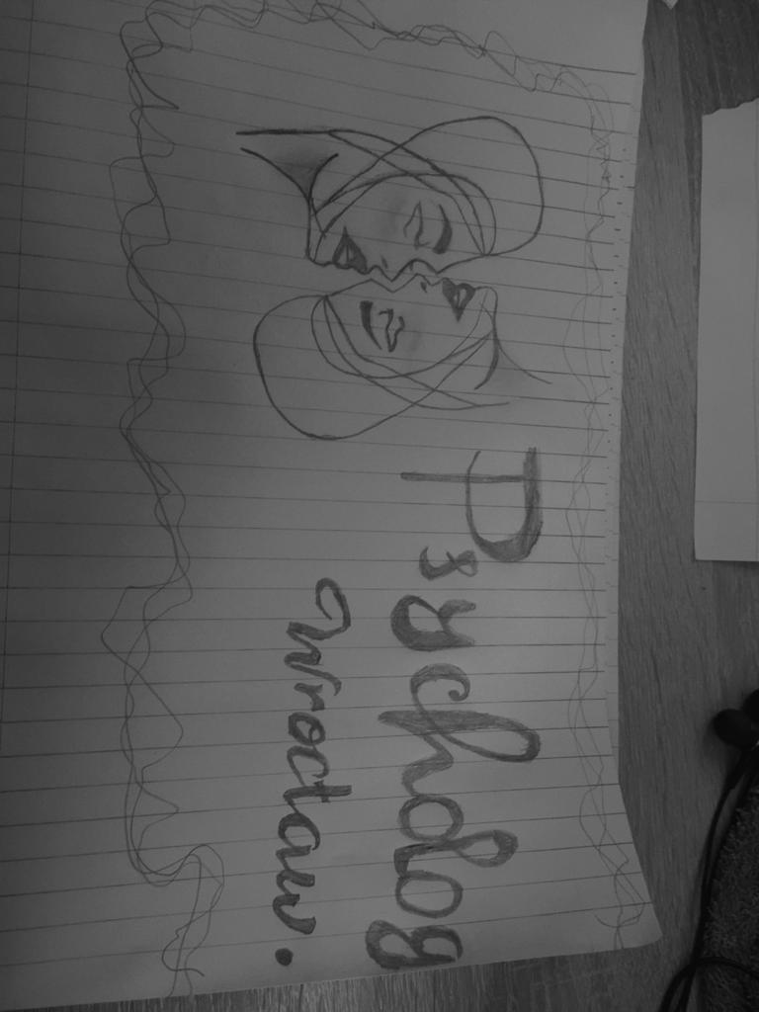

With the full picture of my logo finished all that was left was to digitize the logo and through the use of a pen tool and various brushes. To begin with making the image a vector I had to redraw the main part of the logo in a blank page so it can be cleaner and easier to make it a vector.

3.clean version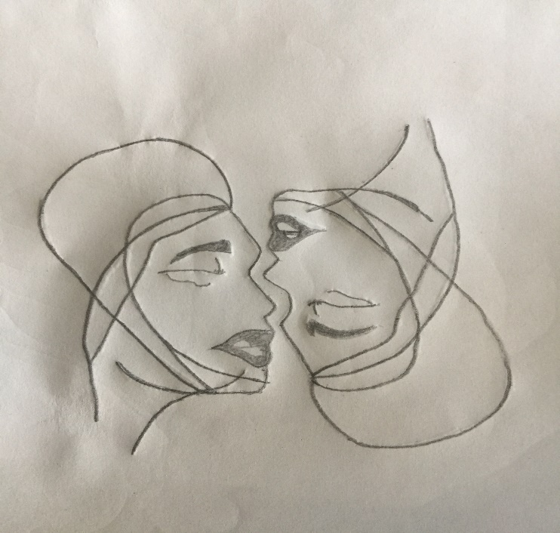

After successfully digitizing my concept all that was left was to make it pop by adding a few color options I realized that it did not look so appealing with the colors and so I decided to step away from colors completely as it gave it a much more formal look.

4. almost there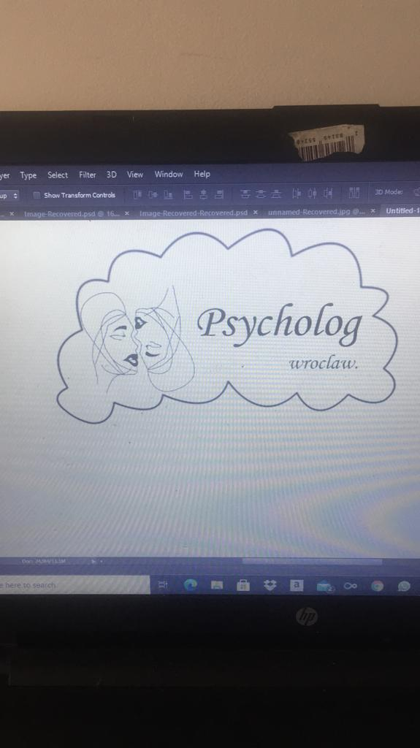

A change in direction

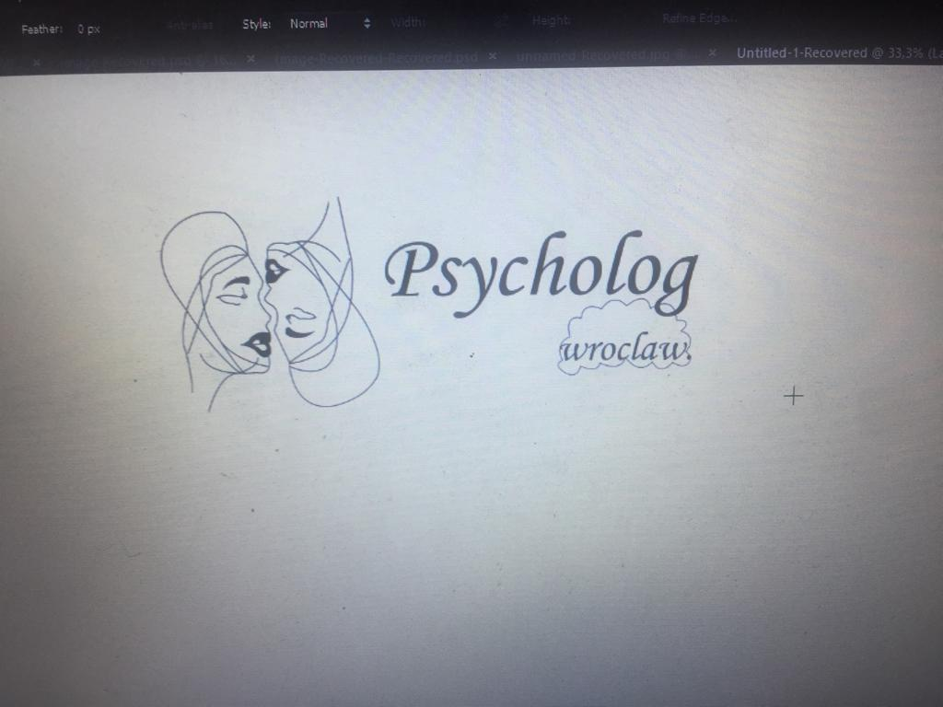

# Skills & Techniques Acquired

Through the duration of this project I learned:

* I now understand the principles and various elements of design
* I have gained practical skills in Adobe software (Illustrator, Photoshop, InDesign)
* the design cycle
* Typography
* How to develop a ‘designer’s eye’. In other words understand the building blocks of visual communication and how to interpret those in a way to satisfy the customers goals.
* non-destructive editing techniques in Adobe Photoshop
* Create logos and branding packages for potential clients

Final product

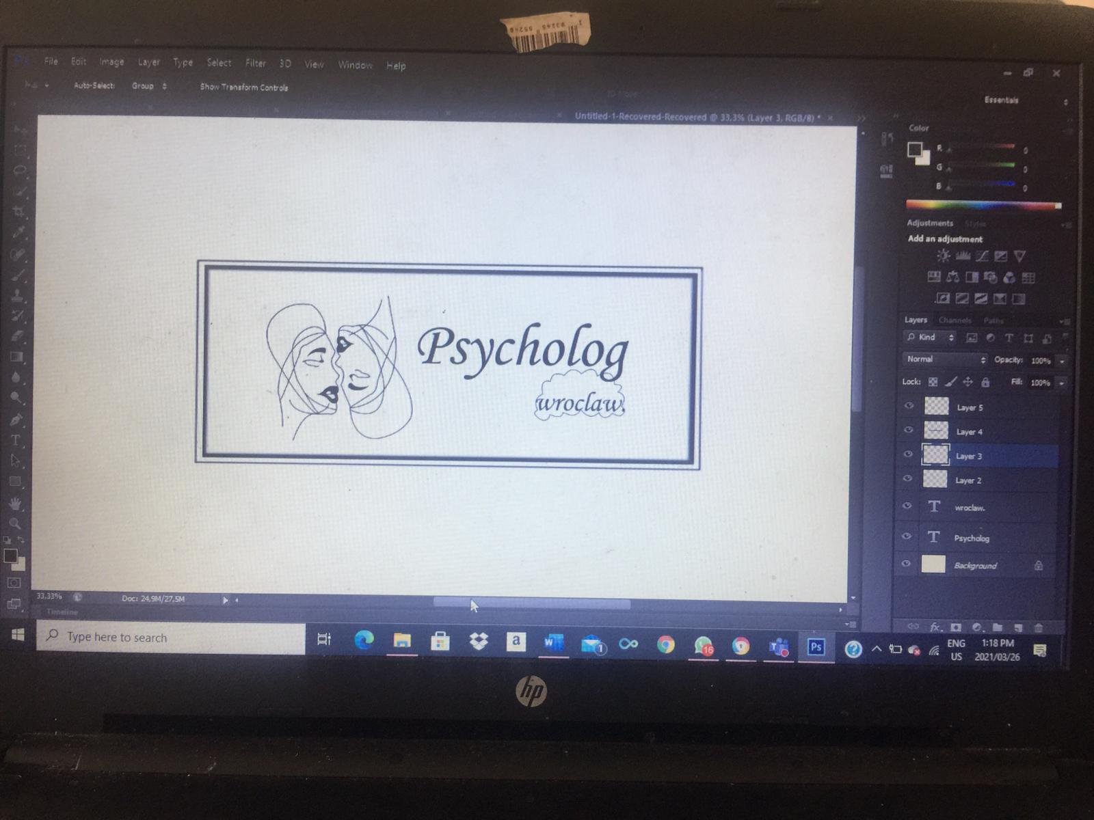

# Conclusion

From the onset I understood that this project would be a fun and educative experience. My final product is proof of my progress as I didn’t have much knowledge to work on. My future hope is that with the online course im taking in addition to the classes takenat school I will be able to do much better designs for companies.